Homojunction GaAs Solar Cells Grown by Close Space Vapor Transport
Jason W. Boucherª, Andrew J. Ritenour^{b}, Ann L. Greenaway^{b}, Shaul Aloni^{c}, Shannon W. Boettcher^{b,*}

ªDepartment of Physics and Materials Science Institute

^{b}Department of Chemistry and Materials Science Institute

University of Oregon, Eugene, OR, 97403, USA
^{c}The Molecular Foundry, Lawrence Berkeley National Laboratory Berkeley, CA, 94720, USA
*email: swb@uoregon.edu

Abstract — We report on the first pn junction solar cells grown by homoepitaxy of GaAs using close space vapor transport (CSVT). Cells were grown both on commercial wafer substrates and on a CSVT absorber film, and had efficiencies reaching 8.1%, open circuit voltages reaching 909 mV, and internal quantum efficiency of 90%. The performance of these cells is partly limited by the electron diffusion lengths in the wafer substrates, as evidenced by the improved peak internal quantum efficiency in devices fabricated on a CSVT absorber film. Unoptimized highly-doped n-type emitters also limit the photocurrent, indicating that thinner emitters with reduced doping, and ultimately wider band gap window or surface passivation layers, are required to increase the efficiency.

Index Terms — semiconductor epitaxial layers, photovoltaic cells, gallium arsenide, III-V semiconductor materials, pn junctions

Introduction
GaAs is an attractive material for high-efficiency photovoltaics, but large-scale production is impeded in part by the cost and toxicity of gas-phase precursors (e.g. arsine and trimethylgallium) employed by metal-organic chemical vapor deposition (MOCVD). Close space vapor transport (CSVT) of GaAs is a plausibly scalable process, similar to commercial CdTe deposition, which uses water vapor to generate gas-phase As₂ and Ga₂O in-situ at atmospheric pressure with high (~1 µm/min) growth rates and ~95% overall transport efficiency [1] – [2].
The reactor used for growth has been described in detail in previous publications [1] – [2]. The reaction
2 GaAs + H₂O (g) ⇌ Ga₂O (g) + As₂ (g) + H₂ (g)
occurs at atmospheric pressure under an H₂ ambient at temperatures typically between 700 and 850 ˚C. Water vapor is provided at controllable levels by varying the relative flow rates of H₂ through a dry line and a line which passes through an H₂O bubbler at constant temperature (10 ˚C). The source and substrate for each growth are separated by a quartz spacer with 0.7-0.9 mm thickness and placed between two graphite heating elements which are independently temperature-controlled.
We recently found that minority carrier diffusion lengths in CSVT-grown GaAs can exceed 3 μm for n-type and 5 μm for p-type material [3]. This is due to the large intrinsic carrier mobilities that are typical of GaAs (μ_{e} = 8000 cm² V⁻¹ s⁻¹, μ_{h} = 400 cm² V⁻¹ s⁻¹). Device simulations predict that pn junction solar cells can reach efficiencies of ~25% with current material quality [4]. We have fabricated and tested pn junction solar cells from GaAs films grown by CSVT. Our results are preliminary but indicate CSVT is a promising method for the growth of high-efficiency GaAs solar cells. Since other III-V materials can be grown by CSVT [5] – [7], it may also offer a cost-effective route to tandem or multijunction solar cell fabrication.

Film Growth and Device Fabrication
A. Growth Conditions
We used source temperatures ranging from of 760 - 850 ˚C and substrate temperatures from 700 – 830 ˚C, and a nominal water concentration of 1000-2000 ppm as measured by an aluminum oxide moisture sensor. Growth temperatures can be reached in approximately 5 min, during which the H₂O concentration is typically ~100 ppm. After heating to growth temperatures, wet H₂ is flowed into the reactor. Growth rates for the emitters are typically ~50-100 nm/min.
For this study, solid GaAs sources containing either Ge or Te at a concentration of 10¹⁸-10¹⁹ cm⁻³ were used to grow emitter films. With the exception of film 9, the substrates used were commercial GaAs wafers grown by the vertical gradient freeze method, such that we could study the quality of the emitter independent of the absorber before growing absorbers using CSVT. Growth conditions are summarized in Table 1. The indicated substrates were etched for 30 s in a 10:1:0.5 H₂O:NH₄OH:H₂O₂ solution prior to deposition of the emitter

B. Device Fabrication
After film growth, front contact grids were fabricated either by photolithography or evaporation of metal through a shadow mask. Fingers defined by photolithography were 20 µm wide, whereas the shadow mask had openings which were 50 µm wide (approximately 2% difference in shading). Ohmic contact was made by sequentially evaporating Ni/AuGe with

TABLE I
Films grown and fabricated into solid state solar cells
Film Number | T_{src} (ºC) | T_{sub} (˚C) | Source Doping (cm⁻³) | Substrate (cm⁻³) | Note
1 | 850 | 830 | Te 1×10¹⁸ | Zn 1×10¹⁸
2 | 850 | 830 | Te 1×10¹⁸ | Zn 1×10¹⁸
3 | 850 | 830 | Te 1×10¹⁸ | Zn 1×10¹⁸
4 | 845 | 830 | Te 1×10¹⁸ | Zn 1×10¹⁸
5 | 850 | 830 | Te 1×10¹⁸ | Zn 1×10¹⁸
6 | 850 | 830 | Te 1×10¹⁹ | Zn 1×10¹⁷
7 | 850 | 830 | Te 1×10¹⁹ | Zn 1×10¹⁷ | Etched substrate
8 | 850 | 830 | Ge 1×10¹⁹ | Zn 1×10¹⁷
9 | 850 | 830 | Ge 1×10¹⁹ | Zn 1×10¹⁷ | On etched CSVT film
10 | 760 | 720 | Te 1×10¹⁹ | Zn 1×10¹⁷
11 | 780 | 720 | Te 1×10¹⁹ | Zn 1×10¹⁷
12 | 800 | 740 | Te 1×10¹⁹ | Zn 1×10¹⁷
13 | 820 | 760 | Te 1×10¹⁹ | Zn 1×10¹⁷

thicknesses of 20 nm/200 nm and annealing under forming gas at 450 ˚C for 2 minutes. Individual mesas were then patterned in photoresist, and the GaAs was etched by citric acid/hydrogen peroxide for 20-30 minutes [8]. The photoresist was subsequently removed with acetone leaving GaAs mesas ~10 µm in height. Back contacts were formed by applying InGa eutectic with a diamond-tipped scribe. Each film contained up to 10 individual 0.2 mm square mesas, depending on the size of the substrate.

- Device Characterization
Current-voltage (IV) curves were measured using a Keithley 2400 source meter. Illuminated curves were measured under 100 mW cm⁻² of AM1.5G simulated spectrum. Films 1-5 gave similar average IV characteristics, as shown inError: Reference source not found Table 2. The variation in these parameters is largely due to the varying emitter thickness (200-300 nm as measured by stylus and optical profilometry), which is influenced by the temperature gradient and source/substrate spacing. Transmission line measurements (TLM) on some of the films yielded resistivities of 0.005 - 0.007 Ω·cm, which corresponds to a carrier concentration of 2-3×10¹⁷ cm⁻³ for uncompensated n-GaAs [9]-[10]. Since this is lower than the source doping, it suggests that the films may be compensated by Zn diffusion from the substrates (which are doped 1×10¹⁸ cm⁻³ for these film.).

Table 2. Average IV characteristics and standard deviations for devices fabricated from films 1-5.
 | Average Value | σ
V_{oc} | 490 mV | 40 mV
J_{sc} | 7.8 mA/cm² | 0.65 mA/cm²
Efficiency | 2.36% | 0.20%
Fill Factor | 62% | 2.2%

Since the IV characteristics were very similar, films 6-13 were grown with much larger changes in the growth parameters including the use of both a different source and substrate. A lower p-type doping level for the substrate was expected to improve the emitter quality by minimizing diffusion of Zn. We also grew one Ge-doped emitter on a Zn-doped CSVT film with a known diffusion length >5 µm (film 9). The IV parameters from these devices are shown in Table 3. A minimum of 5 devices were averaged for each film. Up to 2 outlier devices were removed from each film, which were typically devices at the very edge with contacts shunted to the substrate. The front contact for all of these devices was ohmic without annealing, suggesting the carrier concentration was high. TLM data was inconclusive due to film inhomogeneities. Fig. 1 shows the IV curve from the highest efficiency device.

Table 3. Average IV characteristics of devices fabricated from films 6-13.
Film | V_{oc} (mV) | J_{sc} (mA/cm²) | Eff. (%) | FF (%)
6 | 846 ± 44 | 7.9 ± 0.6 | 4.8 ± 0.7 | 72 ± 7
7 | 872 ± 8 | 8.5 ± 0.4 | 5.5 ± 0.1 | 75 ± 2
8 | 402 ± 91 | 5.7 ± 0.6 | 1.3 ± 0.2 | 60 ± 8
9 | 320 ± 153 | 6.9 ± 1.3 | 1.1 ± 0.6 | 46 ± 7
10 | 834 ± 42 | 12.3 ± 0.2 | 7.1 ± 0.7 | 69 ± 4
11 | 868 ± 35 | 8.3 ± 0.8 | 4.8 ± 1.9 | 64 ± 23
12 | 863 ± 35 | 11.9 ± 0.5 | 7.6 ± 0.4 | 74 ± 2
13 | 783 ± 20 | 10.7 ± 0.8 | 5.7 ± 0.4 | 68 ± 1

A few devices were chosen from each film for quantum efficiency measurements. Fig. 2 shows typical internal quantum efficiency curves (Φ_{int}) for films 6 and 12, which are calculated from the external quantum efficiency by using the known reflectance of planar GaAs [11] and accounting for grid shading. The thickness of film 6 is around 300 nm, which is much larger than optimal since a large fraction of the light is absorbed before reaching the junction [11]. In contrast, film 12 has an emitter only ~100 nm thick and shows an improvement in Φ_{int} for all devices measured, particularly for short wavelengths. Passivation with Na₂S on film 6 yielded only marginal improvement in response below 450 nm. This suggests that the hole diffusion length in the emitter, and not surface recombination, is the present limitation to photocurrent in that wavelength region.

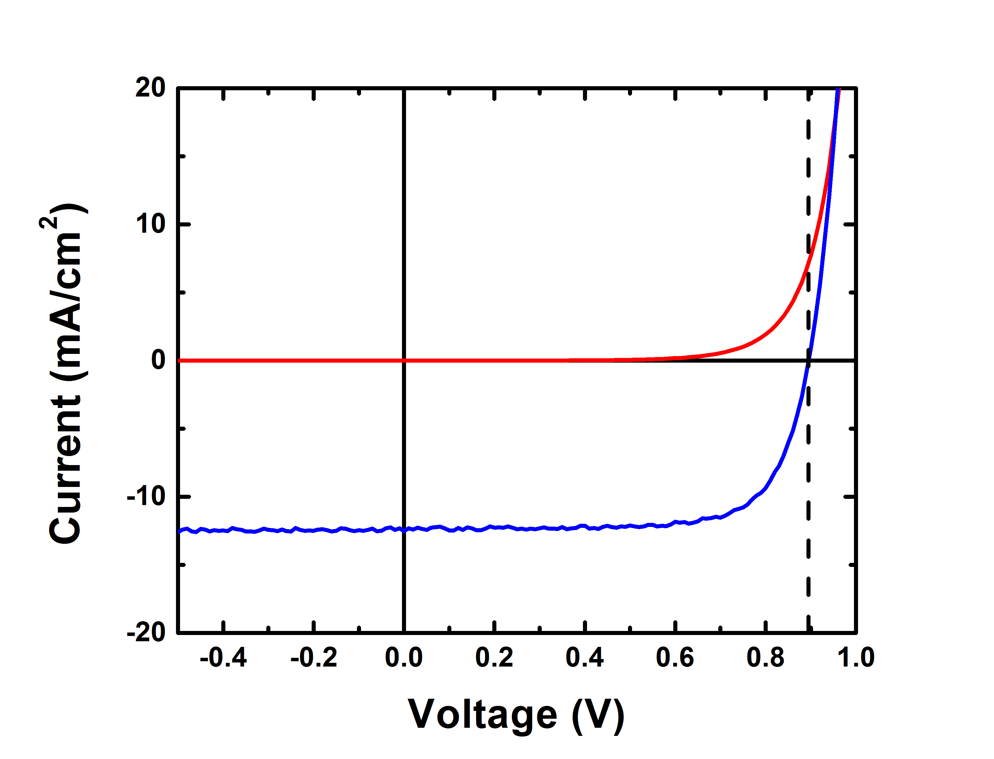
Fig. 1. Light and dark IV curves for the champion device from film 12.

The Ge-doped emitters had lower efficiencies than those doped by Te. However, the peak Φ_{int} is actually much higher for the Ge emitter grown on a CSVT absorber, which is expected given the CSVT absorber material typically has a much longer electron diffusion length than the wafer substrates [3]. Since this emitter thickness was also >300 nm, one of its devices was etched in a solution of H₂O, NH₄OH, and H₂O₂ in a ratio of 90:10:0.25 to observe Φ_{int} as a function of emitter thickness (Fig. 3). Etch rate was measured by optical profilometry on bare GaAs wafers and was approximately 5 Å/s.
A portion of film 9 was sent to Qspec Technology, Inc. for measurement of Zn and Ge concentrations using magnetic sector secondary ion mass spectrometry (SIMS). The SIMS profile (Fig. 4Fig. 4) shows that both Zn and Ge drop below the detection limit over a depth of ~100 nm. A capacitance-voltage profile for a device on this film is shown in Fig. 5 tThe active carrier concentration of4× 10¹⁶ cm⁻³ compared to the SIMS Zn concentration suggests that the p-type film is compensated by n-type dopants to6× 10¹⁶ cm⁻³. This is consistent with the known sulfur background for this reactor measured by time-of-flight SIMS on a number of previously grown GaAs films.

Discussion
SIMS of the all-CSVT pn junction (film 9) show that both layers are doped as expected, and there is relatively little compensation in the emitter layer. Compensation in the absorber is probably due to sulfur contamination rather than diffusion of Ge, as the carrier concentration found by capacitance profiling is constant. This compensation could be limited by careful choice and purification of heating elements (in this study a porous graphite was used for resistive heating), and by source preparation in a clean environment using high purity GaAs powder.

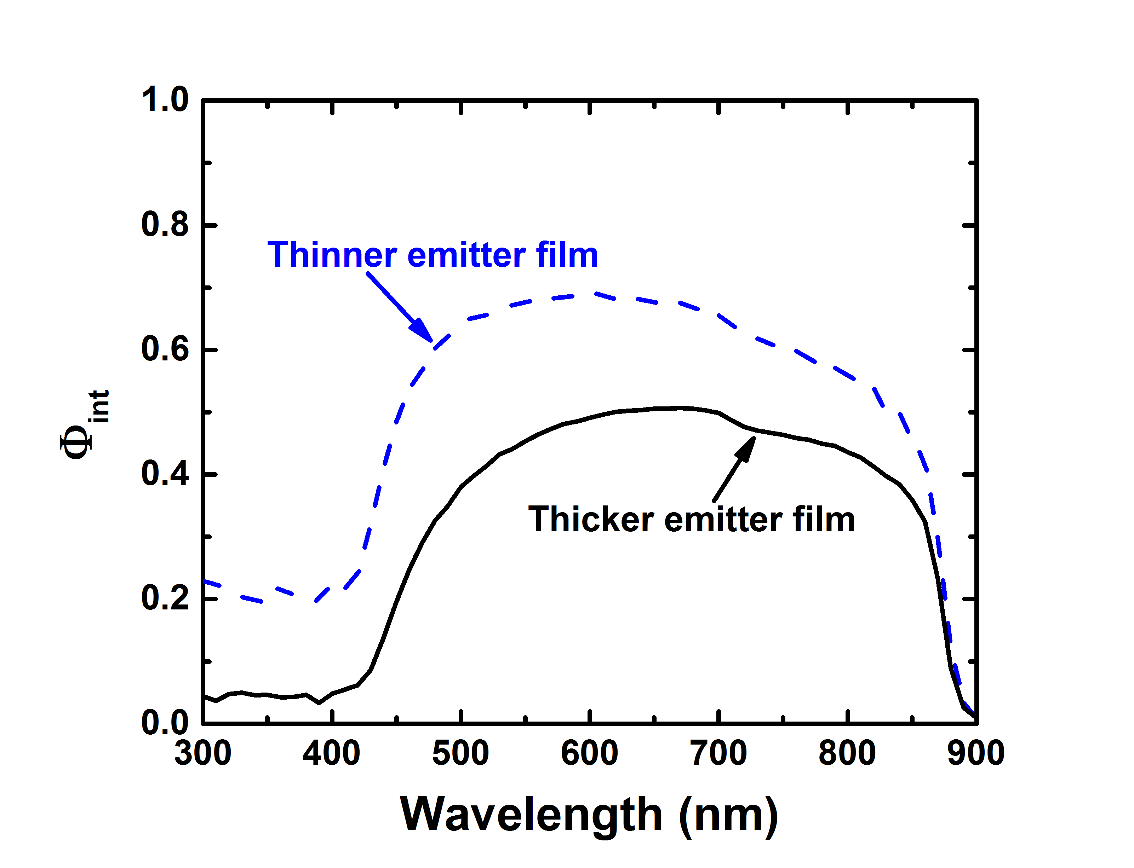
Fig. 2. Internal quantum efficiency for a device on film 6 (black solid curve), and film 12 (blue dashed curve) showing improved response for the thinner emitter film.

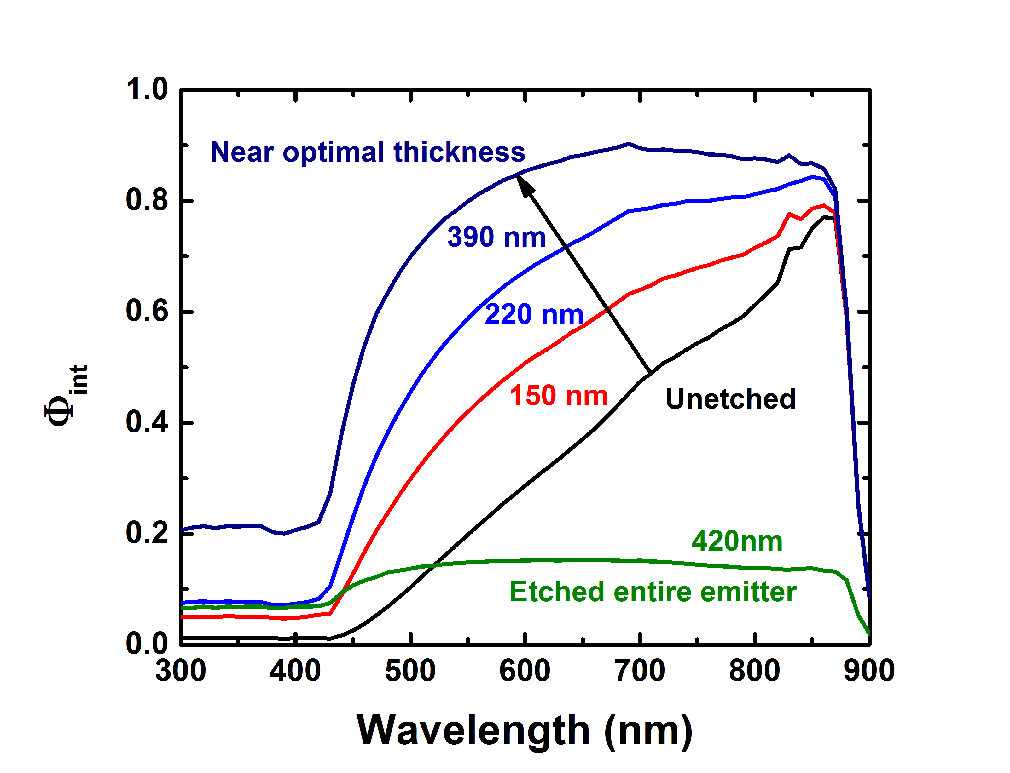
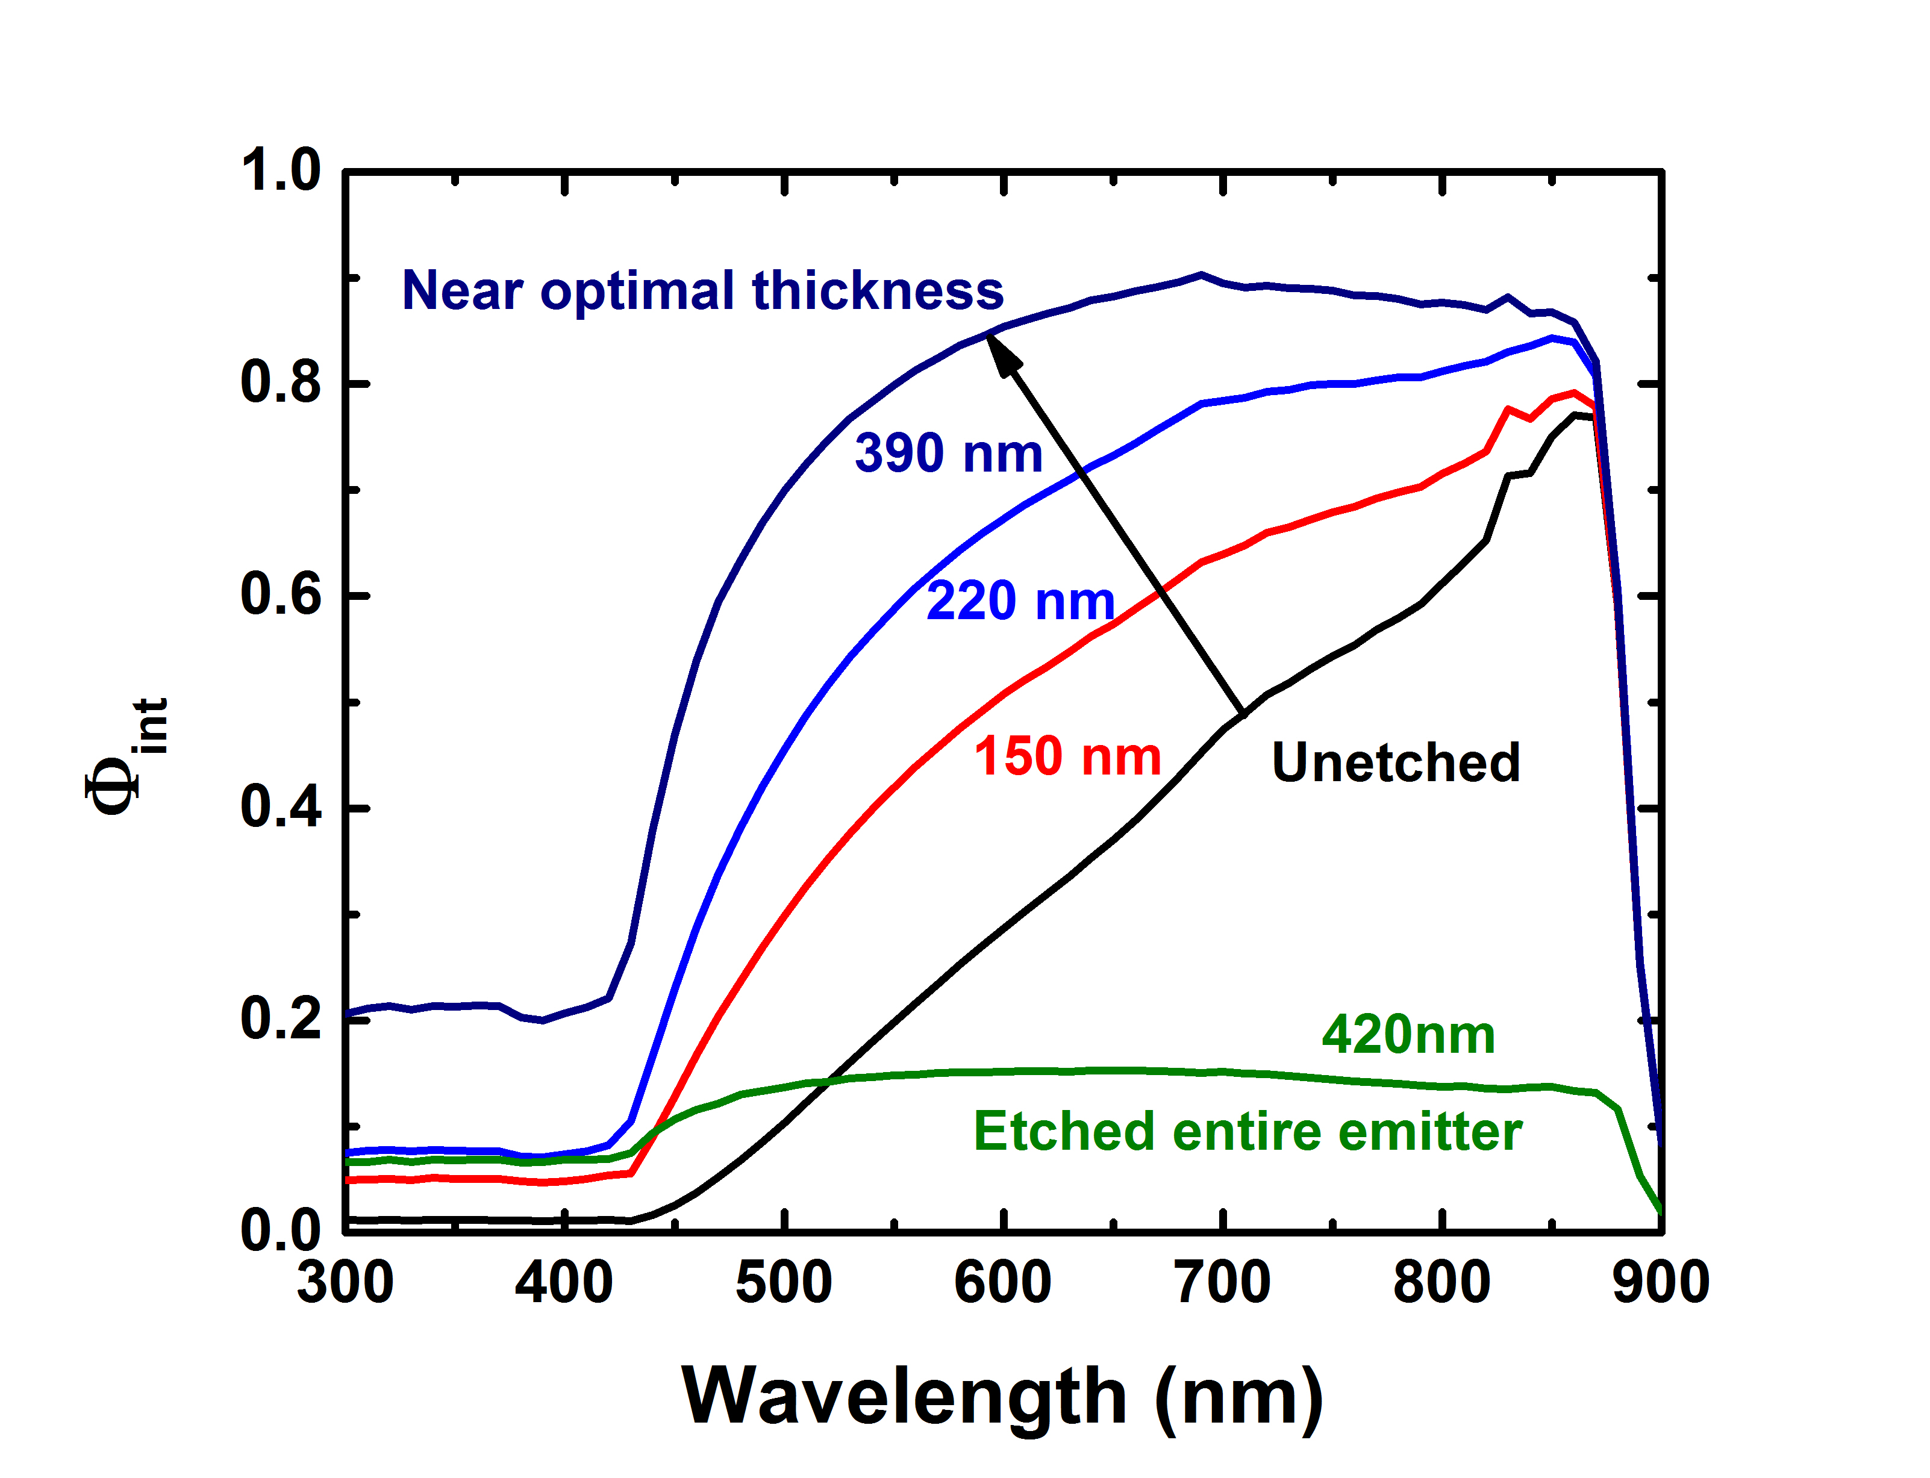
Fig. 3. Internal quantum efficiency at various etch depths for a device on film 9, Ge-doped 10¹⁹ cm⁻³ on Zn-doped 10¹⁷ cm⁻³ CSVT film. The labels indicate the depth etched on the emitter and show that response improves with thinning of the emitter.

These devices are the first GaAs pn junctions grown by CSVT and demonstrate that large photovoltages > 900 mV are possible. Current device efficiencies appear to be largely limited by photocurrent, which can be improved which are

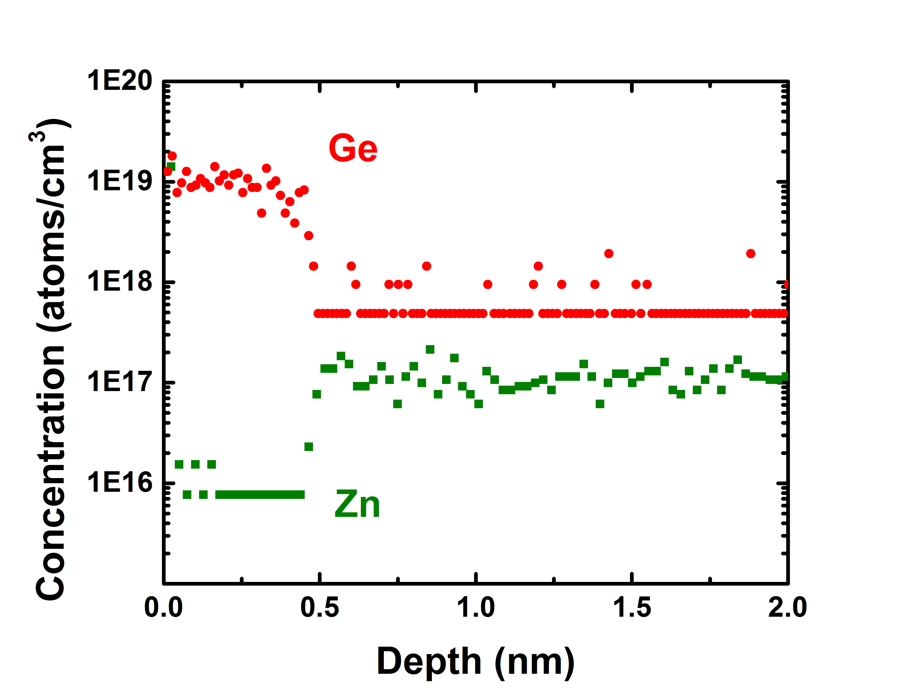
Fig. 4. SIMS profile of Ge and Zn measured on a complete device from film 9 which shows an abrupt junction.

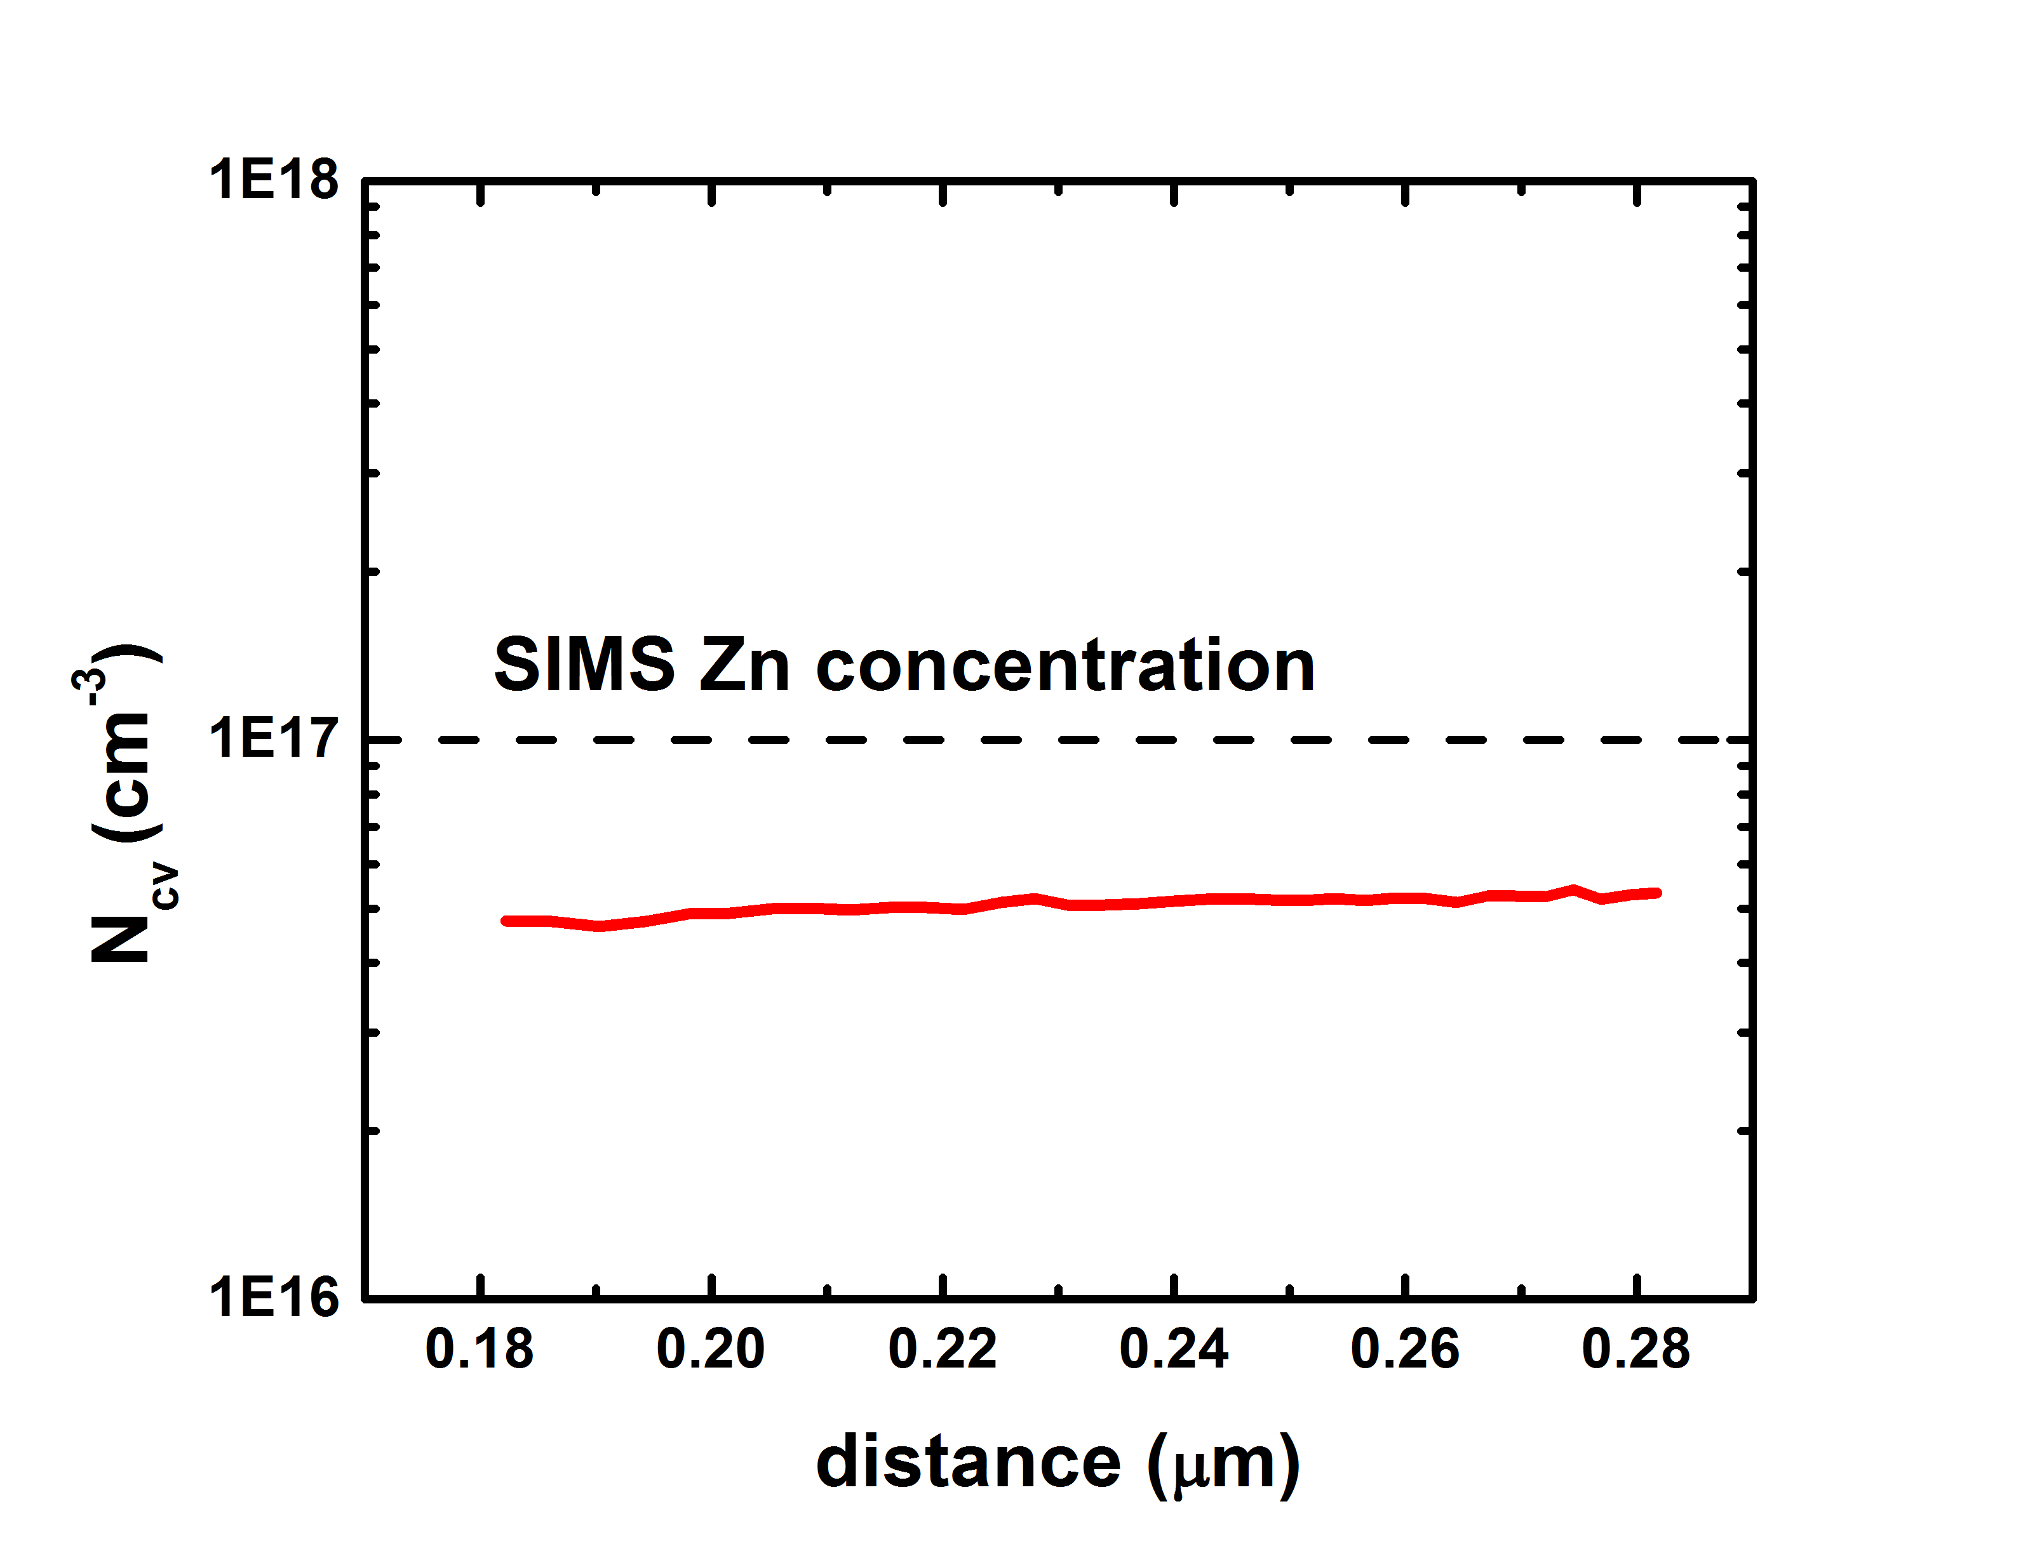
Fig. 5. Carrier concentration determined by capacitance-voltage profiling of a device on film 9 from which the level of compensation can be deduced.

thinner and less highly doped. Thinning the emitters by chemical etching demonstrated that a device with both CSVT-grown absorber and emitter can reach Φ_{int} > 0.9, indicating that higher efficiency cells are possible by optimizing growth rate and time. Future devices will also be grown with a GaAs_{1-x}P_{x} or Ga_{x}In_{1-x}P window layer, which should also be possible via CSVT, and will increase emitter response. Photocurrent may also be affected by defects present at the interface between the absorber and the emitter. In the current reactor design, samples are exposed to atmosphere between growth of the p-type and n-type layers, and midgap states in GaAs have been attributed to interstitial oxygen or oxygen complexes [12] – [13]. Future work using capacitance-based transient spectroscopy will identify trap signatures and correlate defect densities with growth parameters. Tuning growth conditions should lead to significantly enhanced performance based on the intrinsically high material quality obtained by CSVT [3].

Acknowledgements
This work was supported by the DOE SunShot BRIDGE program (DE-EE0005957). ALG was supported by the NSF Graduate Research Fellowship (DGE-0829517). SWB acknowledges support from the DuPont Young Professor Program. We acknowledge the use of the Center for Advanced Materials Characterization in Oregon and the SUNRISE Photovoltaic Laboratory supported by the Oregon Built Environment and Sustainable Technologies (BEST) signature research center.

References
[1] A. J. Ritenour, R. C. Cramer, S. Levinrad, S. W. Boettcher, “Efficient n-GaAs Photoelectrodes Grown by Close-Spaced Vapor Transport from a Solid Source,” ACS Appl. Mater. Interfaces vol. 4, pp. 69-73, 2011.

[2] A. J. Ritenour, S. W. Boettcher, “Towards High-Efficiency GaAs Thin-Film Solar Cells Grown via Close Space Vapor Transport from a Solid Source,” Proc. 38th IEEE Photovoltaic Spec. Conf., pp. 913-917, 2012.

[3] A. J. Ritenour, J. W. Boucher, R. DeLancey, A. L. Greenaway, S. Aloni, and S. W. Boettcher, “High mobility p- and n-GaAs Thin Films Grown by CSVT from Powder Sources,” manuscript in preparation.

[4] J. W. Boucher, A. J. Ritenour, and S. W. Boettcher, “Towards low-cost high-efficiency GaAs photovoltaics and photoelectrodes grown via vapor transport from a solid source,” Proc. SPIE, vol. 8725, 2013.

[5] G. Perrier, R. Philippe, and J. P. Dodelet, “Growth of semiconductors by the close-spaced vapor transport technique: A review,” J. Mater. Res., vol. 3, no. 5, pp. 1031–1042, 1988.

[6] G. E. Gottlieb, “Vapor Phase Transport and Epitaxial Growth of GaAs_{1-x}P_{x} Using Water Vapor,” J. Electrochem. Soc., vol. 112, no. 2, pp. 192–196, 1965.

[7] J. F. Nicolau, K. W. Benz, and J. U. Fischbach, “InP epitaxial growth by the close-spaced method,” Symp. Gall. Arsenide, 1972.

[8] M. Otsubo, T. Oda, H. Kumabe, and H. Miki, “Preferential
Etching of GaAs through photoresist masks,” J. Electrochem. Soc., vol. 123, pp. 676–680, 1976.

[9] S. M. Sze, and J. C. Irvin, "Resistivity, mobility and impurity
levels in GaAs, Ge, and Si at 300 K." Solid-State Electronics vol. 11, pp. 599-602, 1968.

[10] M. Sotoodeh, A. H. Khalid, and A. A. Rezazadeh, “Empirical low-field mobility model for III-V compounds applicable in device simulation codes,” J. Appl. Physics A, vol. 87, no. 6, pp. 2890–2900, 2000.

[11] E. D. Palik, Handbook of Optical Constants of Solids, New York, New York: Academic Press, 1985

[12] G. Masse, M. F. Lawrence, and J. M. Lacroix. "Dominant donor trap in n-type epitaxial GaAs grown by CSVT," J. Phys. Chem. Solids, vol. 49, no. 11, pp. 1349-1353, 1988.

[13] J. Lagowski, D. G. Lin, T. Aoyama, and H. C. Gatos, "Identification of oxygen‐related midgap level in GaAs," Appl. Phys. Lett., vol. 44, no. 3, pp 336-338, 1984.

